Kembu’s Part
I made the + button by using modal within bootstrap, the reason I choose this one is because this one was assigned to me . Also within the button I made a form so you can put in your information, which then would display on the page itself. With that I also made a database with SQL that saves the data you’ve put in. From this project I’ve gotten a greater understanding of bootstrap, I had a great experience with anouar, although I haven’t done much, I was still able to learn a lot from this project.

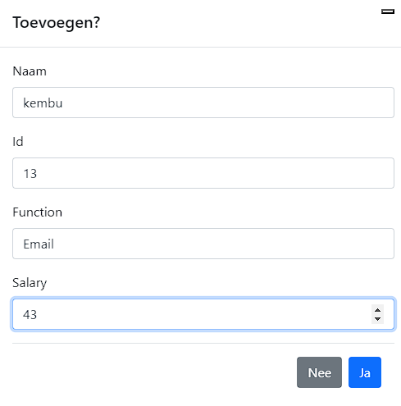
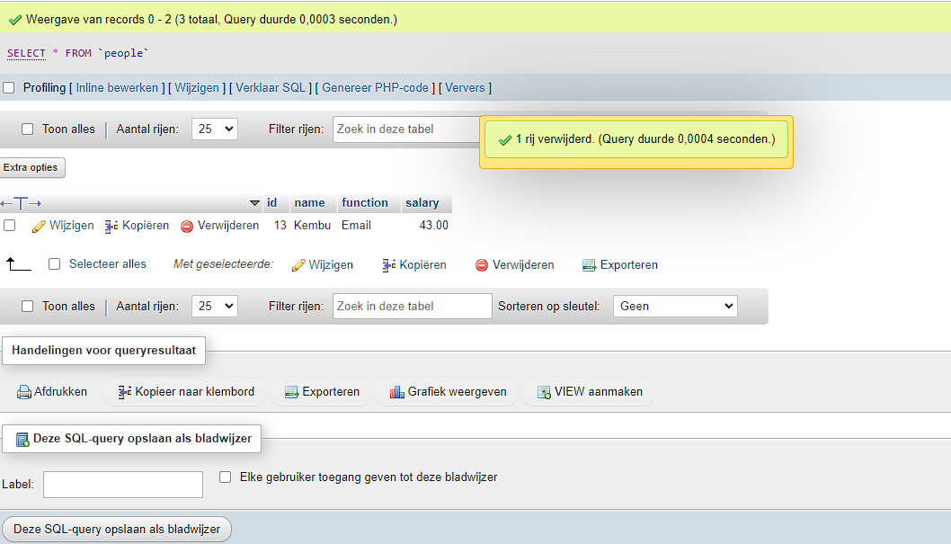
Anouar’s Part
I made remove button by using PHP, The reason I chose PHP is because it’s compatible with SQL and therefore more convenient for me. In addition I also made a update button with bootstrap mixed with PHP, I saw something similar in a YouTube tutorial. In the first place I used 3 different pages and it was very confusing in the end so I removed all the form pages and insert pages an got down to 2: 1 main page that displays an copy of the database. The 2de page is what connects to the database to add a person. The styling is minimalistic because it’s not my greatest concern at the moment. If there is any feedback that I can learn from or better ways of doing things then let me know.
In total there are 3 added functions
Kembu already explained the “add” function
The remove button is the simplest one the way it works is after the remove button is pressed it uses the MYsql query : “DELETE FROM “people“ WHERE id=”$id” LIMIT 1”
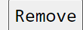
The total function is not very hard: $total_salary += $row[salary]
Picture
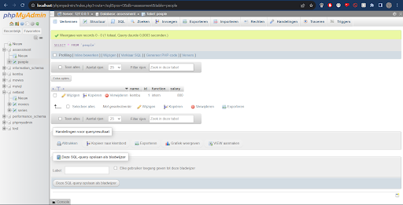

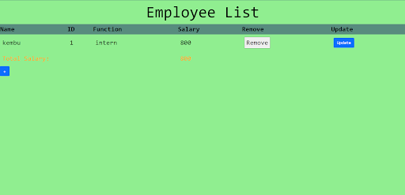

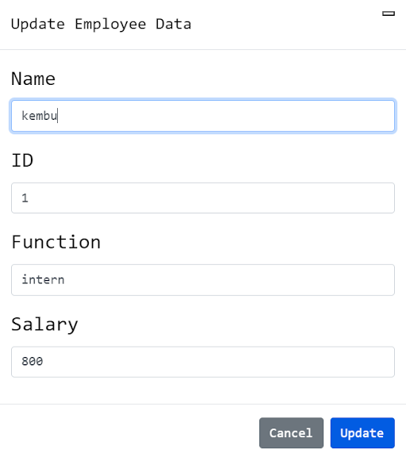

Here’s an example of how Anouar’s update button works
